**SCHOOL OF SCIENCE AND TECHNOLOGY.**

**COURSE:** SPANNING TREE PROTOCOL.

**STUDENT:** Roggers Anguzu.

**INSTRUCTOR:** PROFESSOR: FREDRICK OGORE

**Spanning Tree Protocol.**

The Spanning Tree Protocol (STP) is a network protocol that ensures a loop-free topology in Ethernet networks by preventing broadcast storms and multiple frame copies caused by redundant paths. Developed by Dr. Radia Perlman and standardized as IEEE 802.1D, STP is essential for maintaining network stability and efficiency in environments with multiple interconnected switches.

In complex network architectures, redundant links are often employed to enhance fault tolerance and reliability. However, these redundant paths can introduce network loops, leading to severe issues such as broadcast storms, which can saturate the network with excessive traffic and degrade performance. STP addresses this challenge by selectively blocking some paths while keeping others active, ensuring a single active path exists between any two network devices.

STP operates by electing a root bridge, the central reference point for all path calculations within the network. Each switch determines the shortest path to the root bridge, designating certain ports for forwarding traffic and others for blocking to prevent loops. This dynamic process allows the network to adapt to changes, such as link failures or topology modifications, ensuring continuous, efficient, and reliable operation.

The protocol's ability to dynamically reconfigure the network topology makes it invaluable for modern Ethernet networks, contributing to their robustness and scalability. By implementing STP, network administrators can achieve an optimal balance between redundancy and performance, ensuring seamless communication across the network infrastructure.

**Detailed Explanations.**

What is the Root Bridge?

The root bridge is the logical center of an STP-enabled network. It is the switch with the lowest bridge ID, which combines the bridge priority and the switch's MAC address. The bridge ID is used to elect the root bridge during the STP initialization process.

**Bridge ID.**

The Bridge ID is a unique identifier for each switch and is composed of two parts:

Bridge Priority: A configurable value that has a default of 32,768. Network administrators can adjust this value to influence which switch becomes the root bridge.

MAC Address: The unique physical address of the switch.

The combination of these two values forms the bridge ID. The switch with the lowest bridge ID in the network is elected as the root bridge.

**Functions of the Root Bridge**

Central Reference Point.

The root bridge serves as the central reference point for all path calculations within the network. Every switch in the network determines the shortest path to the root bridge, ensuring a loop-free topology.

Path Cost Calculation.

Each switch calculates the path cost to the root bridge. Path cost is based on the bandwidth of the links; lower bandwidth links have higher costs. The objective is to determine the least cost path to the root bridge.

Root Ports.

Once the root bridge is elected, each non-root switch identifies a single port, known as the root port, that provides the best (lowest cost) path to the root bridge. This root port is used to reach the root bridge. It is mainly determined based on the Lowest cost or MAC addresses or the Lowest Port Number.

Designated Ports and Blocked Ports.

Designated Ports: On each network segment, one port is designated as the forwarding port. This designated port is responsible for forwarding traffic towards the root bridge.

Blocked Ports: To prevent loops, some ports are put into a blocking state. Blocked ports do not forward traffic but can be activated if the network topology changes.

Topology Changes.

When network topology changes occur, such as adding new switches or links or if there is a failure, the STP algorithm recalculates the best paths to the root bridge. This dynamic adaptation ensures that the network remains loop-free and efficient.

Bridge Protocol Data Units (BPDUs).

The root bridge sends Bridge Protocol Data Units (BPDUs) to communicate with other switches. BPDUs contain information about the bridge ID, root path cost, and timers. Other switches use these BPDUs to update their own configurations and ensure they have the most current information about the network topology.

**Election Process**

The election of the root bridge is based on the lowest bridge ID:

1. When STP is initialized, each switch assumes it is the root bridge and sends BPDUs containing its bridge ID.

2. When a switch receives a BPDU with a lower bridge ID than its own, it stops claiming to be the root and forwards the superior BPDU.

3. This process continues until all switches in the network agree on the switch with the lowest bridge ID as the root bridge.

Consider a network with three switches: A, B, and C. Suppose their bridge IDs are as follows:

Switch A: Bridge Priority 32,768, MAC Address 00:11:22:33:44:55

Switch B: Bridge Priority 32,768, MAC Address 00:11:22:33:44:56

Switch C: Bridge Priority 32,768, MAC Address 00:11:22:33:44:57

Switch A has the lowest MAC address, so it becomes the root bridge. Switches B and C will then calculate the shortest path to Switch A, designating their ports as root ports, designated ports, or blocked ports accordingly.

Proper Diagrammatic Illustration.

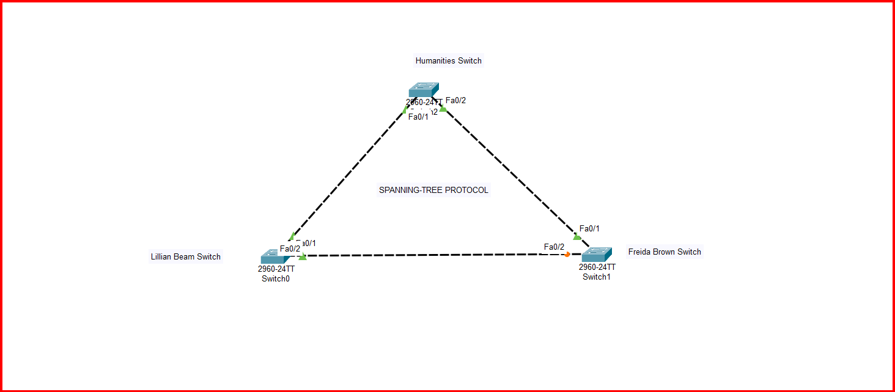

Below shows the Initial State of the Freida Brown Switch before without root.

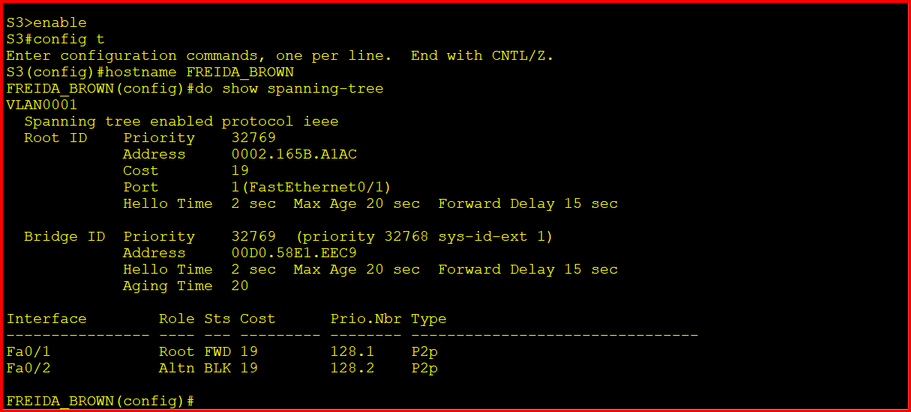

Now it has been changed into the root switch.

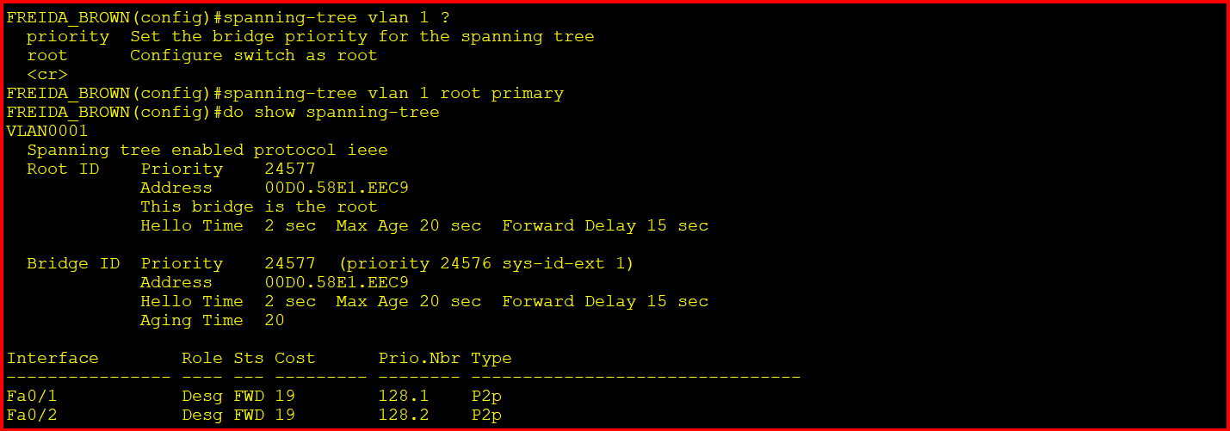

Below is the Lillian beam switch with Spanning Tree.

